Title: Exploring the effects of mixture composition factors and perceptual interactions on the perception of icewine odor: An olfactometer-based study
Authors: Yue MA ^{a, b, c}, Anaïs GUIBERT ^{c}, Noëlle BÉNO ^{c}, Ke TANG ^{a, b}, Yan XU ^{a, b}*, Thierry THOMAS-DANGUIN ^{c}*
ª Lab of Brewing Microbiology and Applied Enzymology, School of Biotechnology, Jiangnan University, 1800 Lihu Avenue, Wuxi, Jiangsu 214122, P. R. China
^{b} Key Laboratory of Industrial Biotechnology of Ministry of Education, State Key Laboratory of Food Science and Technology, Jiangnan University, 1800 Lihu Avenue, Wuxi, Jiangsu 214122, People’s Republic of China.
^{c} Centre des Sciences du Goût et de l’Alimentation, INRAE, CNRS, Institut Agro, Université Bourgogne Franche-Comté, Dijon, France.
* To whom correspondence should be addressed.
(Tel: +86 510 85918197; Fax: +86 510 85918201) E-mail: yxu@jiangnan.edu.cn;
(Tel: +33 380 693084; Fax: +33 380 693227) E-mail: thierry.thomas-danguin@inrae.fr;
E-mail addresses of the co-authors:
Yue MA:yuema@jiangnan.edu.cn
Anaïs GUIBERT: anais.guilbert@inrae.fr
Noëlle BÉNO: noelle.beno@inrae.fr
Ke TANG: tandy81@jiangnan.edu.cn

Abstract
The influence of key odorants of icewine on odor mixture perception and perceptual interactions was explored in a set of 90 mixtures of odorants, which varied in composition. The results showed that the addition of odorants affected both the characteristic odor of the odorants and other odor characteristics in the mixture, and several specific perceptual interactions were revealed for the first time. When one to six odorants were combined with the complex icewine odor, regardless of the combination, a maximum of two corresponding odor characteristics were affected in the mixture. Moreover, the changes in the overall odor profile were more pronounced for the addition of odorants than the omission of odorants, especially when less than three odorants were manipulated. These effects highlight the complexity of the perception of odor mixtures and their intricate effects on the processing of complex food aromas.
Keywords: odor mixture, aroma, odorant, odor quality, odor intensity, olfactory processing, odor combination

1. Introduction
Key odorants of wine aroma have been identified in many different wines (Ma, Xu, & Tang, 2021). However, it is still impossible to predict the final odor perception of wine based on the composition of odorants. The odor perception of wine, as of food in general, is based on the perception of complex mixtures of odorants. However, olfactory processing of the complex chemical signal of these mixtures is still poorly understood. Indeed, highly intricate perceptual interactions have been observed because of the binding and encoding of the chemical signal by the peripheral olfactory system and the further synthetic processing (Livermore & Laing, 1998) or elemental processing (Berglund & Engen, 1993) of the olfactory information. In the end, the odor of mixtures of odorants can be perceived as homogeneous or heterogeneous, and different effects can arise, such as synergy, masking and blending (Thomas-Danguin, Sinding, Romagny, El Mountassir, Atanasova, Le Berre, et al., 2014). Thus, the perception of an odor mixture is not a linear combination of the perceptions of the individual odorants included (Thomas-Danguin, Barba, Salles, & Guichard, 2017).
Wine odor diversity is mainly due to changes in the concentration and combination of numerous odor-active compounds (Polášková, Herszage, & Ebeler, 2008). However, only a small variation in the concentration of one odorant in a complex mixture can modify the overall odor quality (Le Berre, Beno, Ishii, Chabanet, Etievant, & Thomas-Danguin, 2008). Moreover, specific combinations of a few odorants play an important role in the perceptual outcome of an odorant mixture (Barkat, Le Berre, Coureaud, Sicard, & Thomas-Danguin, 2012). In some cases, a single compound, such as linalool in Moscatel wines, can impose its own odor quality on the beverage, but in most situations, various odorants or combinations of odorants, influence the perception of several odor attributes characterizing the product (San-Juan, Ferreira, Cacho, & Escudero, 2011; Siebert, Barker, Pearson, Barter, Lopes, Darriet, et al., 2018). Since the odor profile of a wine is determined by not only the key odorants but also the perceptual interactions between key odorants and/or other odorants, determining the rules and mechanisms of perceptual interactions between odorants is a critical step for identifying the contributing odorants and to predict the final odor perception of wine based on the composition of odorants.
Perceptual interactions between odorants usually found in wines and belonging to different categories have been described in several studies. In brief, esters (Lytra, Tempere, de Revel, & Barbe, 2012; Lytra, Tempere, Le Floch, de Revel, & Barbe, 2013), norisoprenoids, dimethyl sulfide (Escudero, Campo, Fariña, Cacho, & Ferreira, 2007) and some volatile fatty acids (San-Juan, Ferreira, Cacho, & Escudero, 2011) enhance the perception of fruity odors. In contrast, diacetyl, acetoin, acetic acid, γ-butyrolactone (Lytra, Tempere, de Revel, & Barbe, 2012), 4-ethylphenol, acetic acid, phenylacetaldehyde, methional (San-Juan, Ferreira, Cacho, & Escudero, 2011), and a mixture of higher alcohols has a masking effect on fruity odors (Cameleyre, Lytra, Tempere, & Barbe, 2015). Ethyl decanoate and methyl salicylate at subthreshold concentrations were also likely to contribute to the overall odor of Chinese cherry wines (Niu, Wang, Xiao, Zhu, Sun, & Wang, 2019), and various concentrations of ethyl isobutanoate and ethyl isovalerate have additive or synergistic odor effects in mixtures (Niu, Zhu, & Xiao, 2020). Aldehydes such as benzaldehyde, furfural, and vanillin had synergistic effects in the aroma reconstitution of Chinese Huangjiu wine (Yu, Xie, Xie, Chen, Ai, & Tian, 2020). Combinations of some γ-lactones might act additively or synergistically to contribute to the ‘apricot’ odor of white wine (Siebert, et al., 2018). Binary mixtures of monophenols were involved in different perpetual interactions ranging from partly additive to strong synergistic for almost all combinations of monophenols (Sterckx, Missiaen, Saison, & Delvaux, 2011). Ethylphenols had a masking effect on fruity notes of wine even at subthreshold concentrations (Tempere, Schaaper, Cuzange, De Lescar, De Revel, & Sicard, 2016). All these results highlight the complexity of perceptual interactions between odorants. However, few studies have systematically assessed the contributions of different odorant combinations to the odor profile of real products or of complex odor mixtures.
In assessing such contributions, the main challenge is to identify odorants and odorant combinations that are relevant in the context of a real product. Icewine is a good model odor mixture. Icewine is made from grapes naturally frozen on the vine at temperatures below or equal to -7 °C and undergoes a special dehydration process and freeze‒thaw cycles. Since the must for icewine making is pressed from frozen grapes, the grape juice is concentrated, leading to a rich odor after slower-than-normal fermentation (Ma, Xu, & Tang, 2021). The typical odor of icewine has been described as containing odor notes of honey, tropical fruit, apricot, caramel, and raisin as well as nutty and floral (Ma, Xu, & Tang, 2021). Key odorants in icewine and their individual contribution to the typical odor of icewine have been investigated in previous studies (Ma, Béno, Tang, Li, Simon, Xu, et al., 2022; Ma, Tang, Xu, & Li, 2017).. Moreover, wine has been described as a sensory buffer containing the most common odor-active compounds, among which ethyl esters, fusel alcohols, and volatile phenols have been shown to counteract the addition or omission of several odorants without any significant change in the overall odor (Ferreira, 2010). Nevertheless, certain odorants, or families of odorants sharing chemical and odor properties, can overpower the sensory buffer and create an aroma vector specific to the odor features of a real wine. Constructing a wine model from a common base supplemented by six target odor vectors revealed that sensory interactions between the six common aroma vectors can explain four main red wine aroma nuances (Ferreira, Sáenz-Navajas, Campo, Herrero, de la Fuente, & Fernández-Zurbano, 2016). Moreover, aroma vectors can be represented by a single odorant; for instance, ethyl 2-methylbutanoate could replace 14 ester compounds (De-La-Fuente-Blanco, Sáenz-Navajas, Valentin, & Ferreira, 2020). Following this line of reasoning and taking wine as a model odor mixture, the number of odorants can be reduced while still considering the potential interactions among the main aroma nuances.
In this study, we used a novel approach and generated 90 odor mixtures to determine which odorant and odorant combinations impact the overall complex mixture odor. The aim was to highlight the rules that drive perceptual interactions and the causes of the different perceived aromatic notes. We especially considered mixture composition factors such as the number of components, specific associations, and odor intensity.

2. Material and methods
2.1. Chemicals and Samples
Eleven odorants were selected for this study. The odorants (and their purity) were as follows: 3-methyl-1-butanol (CAS no. 123-51-3, > 98%), ethyl 2-methyl butanoate (CAS no. 7452-79-1, ≥ 98%), β-damascenone (CAS no. 23696-85-7, 1.1-1.4 wt. % in 190-proof ethanol), 3-methylbutanoic acid (CAS no. 503-74-2, ≥ 98%), guaiacol (CAS no. 90-05-1, ≥ 99%), furaneol (CAS no. 3658-77-3, ≥ 98%), 1-hexanol (CAS no. 111-27-3, ≥ 98%), phenylethyl alcohol (CAS no. 60-12-8, ≥ 99%), γ-decalactone (CAS no. 706-14-9, ≥ 97%), methional (CAS no. 3268-49-3, ≥ 97%), and 1-octen-3-one (CAS no. 4312-99-6, 50 wt.% in 50% 1-octen-3-ol). Propylene glycol (≥99.9%, food grade) and food-grade odorants were purchased from Sigma‒Aldrich (Saint-Quentin Fallavier, France). Ultrapure water was obtained with a Milli-Q purification system (Millipore, Bedford, MA). Commercial icewine that met the standards of the Vintners Quality Alliance system was purchased from ChangYu Winery (China). Icewine bottles were stored horizontally at 11 °C in the dark before use.
2.2. Stimuli and Delivery Apparatus
The 11 odorants were chosen because they were key aroma compounds in icewine based on a previous study (Ma, Tang, Xu, & Li, 2017) and were also found to impact the whole icewine odor in a study that used an Olfactoscan approach (Ma, Béno, Tang, Li, Simon, Xu, et al., 2022). In addition, six of the 11 compounds were considered part of the common odor of wine (norisoprenoids [N], branched acids [A], enolones [F], branched ethyl esters [E], fusel alcohols [L], and wood compounds [M]) (Ferreira, Sáenz-Navajas, Campo, Herrero, de la Fuente, & Fernández-Zurbano, 2016). The number of odorants used was limited to 11 because of the capacity of the odor delivery system (olfactometer).
For the formal experiment, all the stimuli were delivered by a computer-controlled dynamic-dilution 12-channel olfactometer (OL023; Burghart Instruments, Holm, Germany). The olfactometer allows for the application of rectangular-shaped chemical stimuli embedded into a constant flow of odorless air (Kobal, 1981). The air was humidified, and the temperature stabilized at 25 °C. The total airflow at the outlet of the olfactometer (olfactory port) was kept constant at 3000 mL/min. The stimulus duration was 10 s, and the interstimulus interval (ISI) randomly varied between 40 and 45 s. A brief illustration of the entire experimental setup is shown in Figure 1.
Each odorant solution or icewine was poured into a dedicated chamber of the olfactometer and renewed before each session. Each chamber was connected to a dedicated channel. The left and right channels of the olfactometer were connected to a single outlet at the olfactory port (Figure 1) to increase the number of independent odor channels up to 12. One channel was dedicated to icewine odor, for which real icewine was used; the other 11 channels were used for odorants. For 1-hexanol and phenylethyl alcohol, pure compounds were used; the other nine odorants were diluted in propylene glycol (see details in Supplementary Table 1). A total of 159 stimuli were delivered in three formal test sessions, and 52 stimuli were used in the training session. The stimuli for 4 different blocks in the formal experiment were designed by combining one to eleven odorants (Supplementary Table 2). To deliver the odor stimuli, pure nitrogen was passed through the chamber containing the liquid odor sample to produce odorized air. Different flows of odorized air from different chambers were combined and diluted with humidified odorless air at the outlet of the olfactometer to produce the final odor stimulus. The flow ratio for each stimulus was determined in a pretest involving experienced lab members; if necessary, it was adjusted after the training session involving the external panel to obtain three levels of odor intensity (low, medium, and high) similar for each odor within each level (see details in in Supplementary Table 1).
2.3. Subjects
Thirty-six healthy subjects (50% women and 50% men; age range: 20 to 64 years) were selected three weeks before the main experiment from eighty healthy subjects. Selection was based on two screening tests to evaluate subjects’ (i) ability to maintain selective attention over time using the Bourdon test (Bourdon T.I.B. test, Swets & Zeitlinger BV, Calisse, The Netherlands) and (ii) performance in detecting and identifying different odors at low to medium intensity. The 36 subjects with the highest scores on both tests were selected to participate in the study. All of the subjects confirmed that they were in good health and had normal olfactory abilities during the experiment. The study followed the recommendations of the Declaration of Helsinki and was in accordance with the French regulations concerning research involving human volunteers (‘étude hors-RIPH ne visant pas le développement des connaissances biologiques ou médicales’). Subjects provided written consent after being informed about the aims and potential risks of the study. They were instructed not to wear any perfume and not eat or drink anything for at least 1 hour before the study. Subjects received a 10 € gift card for each hour of participation.
2.4. Experimental Procedure
The experiment included one training session and three test sessions. All the stimuli in these sessions were delivered by the olfactometer (Figure 1). All the sessions were conducted individually in an air-conditioned room. During the experiment, the subjects were seated in a booth (isolated from external odors, noises or visual stimuli), in which the olfactometer’s olfactory port was located. They received a light cue when a stimulus was delivered, and they were asked to evaluate perceived odor characteristics following a rate-all-that-apply (RATA) procedure (Ares, Bruzzone, Vidal, Cadena, Giménez, Pineau, et al., 2014). Subjects used a computer system running FIZZ sensory analysis software (version 2.51, Biosystemes, Couternon, France) to record their responses.
Every selected subject participated in a training session prior to the test sessions to become acquainted with the olfactometer, the different odor descriptors and the details of the experimental procedure. The training session included three phases. In the first phase, the 11 basic (unmixed) odors were delivered at medium odor intensity, and their target descriptors were provided to subjects in a fixed order. The subjects were asked to remember the descriptor dedicated to each odor (Supplementary Table 1). In the second phase, the 11 basic odors were delivered again at medium odor intensity but in a random order. The subjects were asked to recognize the odor by selecting the expected descriptor from the list provided on the computer screen. In the third phase, the RATA procedure was introduced, and subjects were asked to evaluate 30 odor stimuli using the RATA scales (see below) displayed on the computer screen. This last procedure was the same procedure used during test sessions.
The test sessions comprised a total of 159 odor stimuli divided into 4 separate blocks (blocks A, B, C, and D; Supplementary Table 2); the data of blocks C and D were not analyzed. Block A consisted of the real icewine odor spiked with the odor of each individual odorant (11 odorants tested) at one intensity level (3 intensity levels tested). Block B consisted of the real icewine odor spiked with combinations of up to 6 odorants (6 odorants out of 11). The stimuli from the 4 blocks were divided evenly to ensure that each of the 3 test sessions comprised the same number of samples (55 odor stimuli including the control and warm up). The order of the blocks was balanced across subjects to minimize the order effect. In each session, the subject began with 2 warm-up stimuli and then the 53 test stimuli. The first warm-up stimulus was a single odorant, and the second was a real icewine odor. The presentation order of the test stimuli was random and different for each subject. The duration of each odor stimulus was 10 s, and the interstimulus interval ranged randomly between 40 and 45 s to maintain subject vigilance. During a session, the subject was given a 2-minute break after every 15 stimuli. Each session lasted approximately 1 h.
2.5. The Rate-All-That-Apply (RATA) Procedure
In the RATA procedure, subjects sniffed the odor stimuli in front of the sniff port of the olfactometer when the cue (red light) was presented. Then, they were asked to check different terms they considered appropriate for describing the odor stimuli and to rate the intensity of the selected terms using a 5-point scale (very low, low, medium, high, or very high). There were 13 odor descriptors (hereafter, attributes) provided (in French): alcohol ("alcool"), apricot ("abricot"), caramel ("caramel"), cheese ("fromage"), cooked potato ("patatate cuite"), green ("vert/herbe coupée"), honey ("miel"), mushroom ("champignon"), nut ("noisette"), raisin ("raisin sec"), rose ("rose"), smoke ("fumé"), and tropical fruit ("fruits tropicaux"). These terms were selected based on the descriptor for each odorant obtained in GC-O analysis or previous descriptive analysis using similar icewines (Huang, et al., 2018; Ma, Tang, Xu, & Li, 2017).
2.6. Data Processing
The raw data are accessible on a data repository (Thomas-Danguin & Ma, 2023). All statistical analyses were performed with R software (version 3.5.3, R Foundation for Statistical Computing, Vienna, Austria.). Subjects’ ratings with the RATA procedure were transformed into numerical values from 1.0 (very low) to 5.0 (very high). The value for the terms that were not selected was set to 0.
The quality of sensory data was assessed with ANOVA (panelperf function from the SensoMineR package (Husson & Le, 2008)) in two data subsets, in which the dependent variables were the thirteen attributes and the independent variables were the factors associated with the sample effect, the subject effect, the session effect, and all their first-order interactions. The ANOVA results were used to test the sensory panel ability to differentiate the samples (discrimination) consistently (repeatability) and consensually (agreement). If there was a significant sample effect, the panel discriminated the samples with respect to the target sensory attribute (discrimination); if there was a significant sample × subject interaction, subjects did not have the same perception of the samples with respect to the target sensory attribute (no agreement); if there was a significant sample × session interaction, subjects were not consistent among sessions.
The perceptual impact of the odor stimuli in terms of odor Modified Intensity (MI) was assessed. MI values were calculated using Equation 1, where F was the percentage of subjects who selected a given attribute and A was the average intensity rating of subjects who selected the attribute. The MI value was calculated for each odor attribute and each sample and further used to estimate perceptual impact instead of the mean intensity values because this index includes both selection frequency and odor intensity for a given descriptor (San-Juan, Pet'ka, Cacho, Ferreira, & Escudero, 2010). MI values were used to construct the odor profile of each sample and to run further multivariate analyses. The odor profile of each sample was visualized using the radarchart function from the fmsb package (Nakazawa & Nakazawa, 2017).
MI=$\sqrt{F×A}$ (Equation 1)
For each odor attribute, the difference between the values of 1) icewine (R6) and the icewine + six-odorant combination (sample B6-R6L1L2L3L4L5L6); 2) icewine (R6) and icewine + individual-odorant combinations (the addition condition); and 3) icewine + six-odorant combination (sample B6-R6L1L2L3L4L5L6) and icewine + individual-odorant combinations (the omission condition) in blocks A and B was analyzed by two-sided paired Wilcoxon test using the wilcox.test function from the ddply package (Wickham, 2011). The statistical significance level was set at p ≤ 0.05.
The relationship between sample attributes and samples was analyzed by conducting a cluster analysis with the MI values of the 13 attributes for each sample and further visualized through the Heatmap function from the ComplexHeatmap package (Gu, Eils, & Schlesner, 2016). The Euclidean distance was used in the clustering process.

3. Results
3.1. Sensory Data Quality Assessment
The quality of the sensory data was assessed with ANOVAs to determine subject performances in two subsets of data. In the first subset, we evaluated within-subject repeatability using replications of the same icewine sample in 3 different sessions. In the second subset, we evaluated the discriminative ability of the subject using the data obtained for 6 different odor mixtures rated in 2 different sessions. The ANOVA results (Supplementary Table 3) showed that the sample effect was not significant for any of the attributes, which suggests that subjects were repeatable in evaluations of the same sample of icewine across sessions. The sample × subject interaction was significant for the rose (p= 0.006) and honey (p= 0.027) descriptors, which suggests that the panel members evaluated all descriptors in a similar way except these two. The sample × session interaction was significant only for the rose (p= 0.026) descriptor, which suggests that subjects were repeatable in cross-session evaluations of all descriptors except for rose.
The MI values of each odor attribute of the icewine odor sample in each session and the average across sessions were used to construct the icewine odor profile (Supplementary Figure 1). The average profile indicated that icewine was mainly characterized by odors of tropical fruit, alcohol, honey, and apricot, a result in line with previous data, except for the attribute alcohol, which was not selected in the previous study (Ma, Tang, Xu, & Li, 2017). A paired two-sided Wilcoxon test was performed to compare the MI values of each attribute in each session to the average across sessions. The results revealed only a few likely inconsistent differences for the descriptors nut, rose and apricot. Overall, this first analysis highlighted the good repeatability and consistency of the panel.
In the second analysis, we evaluated the discriminative ability of subjects using a second subset of data obtained for six different icewine odor mixtures rated in two different sessions. The samples were prepared by separately combining one of the six medium-intensity individual odorants (3-methyl-1-butanol, ethyl 2-methyl butanoate, β-damascenone, 3-methylbutanoic acid, guaiacol, and furaneol) with the icewine odor. The ANOVA results (Supplementary Table 3) showed a significant sample effect on 7 of the 13 descriptors (alcohol, tropical fruit, honey, cheese, smoke, caramel, and apricot). Since the six odorants added to the icewine odor corresponded to these 6 attributes, with the exception of apricot, which was not a target descriptor, it can be concluded that the subjects were able to differentiate the odor mixtures samples but also to correctly identify the odor quality of the odorant added to the icewine odor. The sample × subject interaction was significant for 4 descriptors (cheese, smoke, cooked potato and raisin), and the sample × session effect was significant only for the raisin descriptor, which suggests that the panel provided consistent results and that the subjects were in agreement for most of the descriptors.
In summary, considering these two analyses related to the panel performance, subjects were able to correctly perform the RATA task and provided repeatable, consistent, and in-agreement data.
3.2. Influence of the Addition of Individual Odorants on the Perception of the Icewine Odor
The stimuli in block A (see details in Supplementary Table 2) were designed to test the influence of the odor intensity of the added individual odorant on the perception of the icewine odor. In this test, 11 odorants were individually added at low, medium, and high intensity to the icewine odor. The RATA data for the thirteen attributes were compared between the odor mixtures and the basic icewine odor using a paired two-sided Wilcoxon test. MI values were further used to construct odor profiles for each of the 33 samples (11 odorants × 3 intensity levels, Supplementary Figure 2).
The results showed that the addition of an individual odorant to the icewine odor could have several outcomes: 1) the intensity of the attribute most closely related to the odorant added increased in the profile (see the example in Figure 2a); 2) the intensity of attributes less strongly or not related to the added odorant increased or decreased (see the example in Figure 2b); or 3) no significant change was observed regardless of the attribute (see the example in Figure 2c).
Regarding the first outcome, adding 3-methylbutanoic acid (L4, cheese), guaiacol (L5, smoke), γ-decalactone (R3, apricot), methional (R4, cooked potato) or 1-octen-3-one (R5, mushroom) to the odor of icewine (R6) significantly increased the intensity of the target attribute of the added odorant regardless of intensity level. For ethyl 2-methyl butanoate (L2, tropical fruit), β-damascenone (L3, honey or apricot), 1-hexanol (R1, green) and phenylethyl alcohol (R2, rose), the target attribute’s intensity increased significantly only at medium or high intensities of the added odorant. For 3-methyl-1-butanol (L1, alcohol or cheese) and furaneol (L6, caramel), no significant modification of the target attribute intensity was observed, regardless of the intensity level.
Regarding the second outcome, we observed that the addition of an individual odorant to the icewine odor led to the modification of attributes not directly related to the added odorant. For instance, adding furaneol at medium or high intensities enhanced the intensity of the raisin descriptor, while adding 1-hexanol at low intensity or ethyl 2-methyl butanoate at medium intensity enhanced apricot. The addition of γ-decalactone at high intensity enhanced alcohol and the addition of methional at medium or high intensities enhanced cheese. Some odorants, added at a specific intensity level to the basic icewine odor, decreased the intensity of attributes: adding 3-methyl-1-butanol at low or high intensities decreased rose and tropical fruit, adding ethyl 2-methyl butanoate at medium or high intensities decreased green, adding ethyl 2-methyl butanoate at high intensity decreased cheese and smoke, and adding β-damascenone at low intensity decreased alcohol. Adding β-damascenone and furaneol decreased cheese at all intensity levels; adding 3-methylbutanoic acid at medium or high intensities decreased tropical fruit and honey; adding guaiacol at high intensity or 1-hexanol at low or high intensities decreased tropical fruit; adding phenylethyl alcohol at high intensity decreased tropical fruit and alcohol; adding γ-decalactone at medium or high intensities decreased smoke; adding methional at medium or high intensities decreased rose, alcohol and tropical fruit; and adding 1-octen-3-one at any intensity decreased alcohol.
The third outcome was less often observed since only the addition of 3-methyl-1-butanol at medium intensity and phenylethyl alcohol at low intensity failed to induce significant changes in any attribute.
To provide an overall picture of the effects induced by adding each of the 11 odorants to the icewine odor, we performed a cluster analysis using the MI values of each attribute (calculated as the difference between after and before adding the odorant) (Figure 3). The results of the classification help to illustrate the main trends. First, the profile of the icewine odor was modified in a similar way after the addition of ethyl 2-methyl butanoate, β-damascenone, or γ-decalactone at all intensity levels, resulting in an increased intensity of the attributes raisin, honey, tropical fruit, and apricot and decreased intensity of nut, green, cooked potato, cheese and smoke. Second, this analysis showed that the addition of 3-methylbutanoic acid or 1-octen-3-one, regardless of the intensity level, increased the perception of their own odor (cheese or mushroom, respectively), while adding 1-octen-3-one also decreased odor notes of alcohol, caramel and honey. Similarly, adding furaneol, 1-hexanol, phenylethyl alcohol, guaiacol, or methional at medium or high intensities led to an increased perception of their own odor (caramel, green, rose, smoke, or cooked potato, respectively), while the addition of these compounds at low intensity levels induced a different icewine odor profile modification (Figure 3). For instance, the addition of furaneol, 1-hexanol, phenylethyl alcohol or methional at low intensity had similar effects on the icewine odor profile, with slight modifications of the descriptors alcohol, nut, green, rose and cooked potato. Third, it is worth noting that the addition of 1-hexanol or methional at medium and high intensity levels had strong suppressive effects. Indeed, the addition of 1-hexanol decreased fruity odors (apricot, tropical fruit and raisin), while the addition of methional led to a decrease in the intensity of all fruity and floral odor notes.
3.3. Influence of the Combined Addition of Odorants on the Perception of Icewine Odor
The stimuli in block B (see details in Supplementary Table 2) were generated to determine the perceptual influence of the addition of combinations of odorants (two- to six-odorant combinations) to the icewine odor. Six odorants, identified by Ferreira et al. (Ferreira, Sáenz-Navajas, Campo, Herrero, de la Fuente, & Fernández-Zurbano, 2016) to contribute to wine aroma vectors, were added at medium intensity to the icewine odor stimulus. Thus, in block B (and part of block A to assess individual-odorant additions), a total of 63 combinations of 1 to 6 odorants were tested. For the 13 odor attributes, the difference between a given odor combination with icewine odor and the basic icewine odor was determined with a paired two-sided Wilcoxon test. The MI values of each attribute for the 63 samples were used to construct odor profiles (Supplementary Figures 3-7). The first result is related to the combination with the most complex six-odorant mixture. This sample involved the addition of 3-methyl-1-butanol, ethyl 2-methyl butanoate, β-damascenone, 3-methylbutanoic acid, guaiacol, and furaneol at medium intensity to the icewine odor. The odor profile of this sample (Figure 2f) did not significantly differ from the basic icewine sample (p> 0.05, Wilcoxon test), except for the attribute nut (however, the MI values were approximately 0; thus, this attribute was not further considered). Therefore, it is likely that the combination of these 6 odorants reflected the overall icewine odor; in other words, this combination did not distort the overall profile when added to the icewine odor.
Regarding the addition of combinations of 2 to 5 odorants, the results are similar to the addition of individual odorants in that 3 main outcomes were observed as follows: 1) an increase in the intensity of odor notes related to the added odorants, but with at most only two attributes significantly modified regardless of the added-mixture complexity (see the example in Figure 2d); 2) modification of other attributes (see the example in Figure 2e); or 3) no major modification of the icewine odor profile (see the example in Figure 2f). Overall, the different effects induced by odorants addition could be classified into 6 different categories, whose occurrence is reported in Table 1. It was difficult to extract general trends, but it seemed that the most frequent situation was the significant modification of only one odor descriptor associated with one of the added odorants (category ‘One-D’ in Table 1). Moreover, especially for the less complex combinations (1 to 3 odorants), the second most often observed modification of odor descriptors was unrelated to the manipulated odorants (‘One-D & U’). With combinations including more than 3 odorants, the change in only two target attributes (‘Two-D’) shifted to the modification of two target attributes accompanied by the modification of other unrelated attributes (‘Two-D & U’).
Interestingly, it is possible to consider these data not only from the perspective of odorant addition but also from the perspective of odorant omission (of 1 to 6 odorants). From this perspective, the reference sample for the comparison was not the basic icewine sample but the mixture of the 6 odorants added to the icewine odor (coded B6-R6L1L2L3L4L5L6). Thus, the basic icewine becomes the mixture in which the 6 compounds were omitted. Considering the 6 categories of perceptual effects mentioned in Table 1, it can be seen that when 1 to 6 odorants were omitted from the reference sample (B6-R6L1L2L3L4L5L), the percentages of only one odorant-related attribute change (‘One-D’) were lower than those under the addition perspective. However, the categories in which one odorant-related attribute changed simultaneously with changes in other attributes (‘One-D & U’), in which other attributes not related to the omitted odorants changed (‘U’), or in which no change was observed (‘N’) were the most frequently observed. It should be emphasized that we observed a modification of 3 odorant-related attributes only once. This case, not reported in Table 1, was observed for sample L1L2L3L5L6, in which 3-methyl-1-butanol, ethyl 2-methyl butanoate, β-damascenone, guaiacol, and furaneol were omitted. In that case, the three attributes related to ethyl 2-methyl butanoate (tropical fruit), β-damascenone (honey), and furaneol (caramel) had a reduced intensity.
A visual summary of the comparison of the addition and omission perspectives is presented in Supplementary Figure 8. We observed that the omission of certain odorants or combinations had less effect on the profile of the icewine odor than their addition. The main effect of omission influenced other attributes than those related to the manipulated odorants. In contrast, the addition of certain odorants led to the modification of not only the odorant-related attribute but also of other attributes. This result suggests that the olfactory system is more sensitive to the addition of odorants than to their omission, especially when fewer than three odorants were manipulated.
To explore the relationships between the overall odor profile of the icewine and the overall odor profile of the icewine supplemented with odorants, a cluster analysis was performed on the MI values. The results, shown in Figure 4, illustrate the odor profiles of different odors, including the icewine odor spiked with a combination of odorants (one- to six-odorant combinations) at medium intensity and the basic icewine odor. The hierarchical analysis indicated that the samples could be roughly divided into three groups according to the evolution of the MI values of the different attributes. The odor profiles of the samples in the group on the left side of Figure 4 were the closest to the odor profile of the basic icewine odor since this group included the icewine sample. Interestingly, the number of added odorants in these samples was mostly between 3 and 6. This result suggests that when more than three odorants were added to the icewine odor, the effect on the overall odor profile was generally small. The odor profiles of the samples in the group shown in the middle of Figure 4 had increased MI values with odorant addition for the attributes cheese, cooked potato, smoke and green. This group included samples with 3-methylbutanoic acid and/or guaiacol, which led to the enhanced perception of at least one descriptor related to one of these odorants. This finding suggests that these two compounds dominated the odor of the mixture. The odor profiles of the group shown on the right side of Figure 4 had increased MI values with odorant addition for the attributes tropical fruit, apricot, honey and caramel. These samples included the least complex combination, i.e., mostly two-odorant and three-odorant combinations, and notably excluded 3-methylbutanoic acid and/or guaiacol, which suggests that these compounds tend to mask the fruity and sweet attributes.
Figure 4 also shows that several pairs of samples shared the closest odor profile, such as the pair of B1-R6L3 and B3-R6L1L2L3, and the pair of B3-R6L2L4L5 and B4-R6L2L4L5L6. The pairs of samples sharing the closest odor profile were typically formed by adding different numbers of odorants; however, some pairs of samples sharing the closest odor profile were formed by adding the same number of odorants; these samples are marked in Figure 4 in green squares.
Among all 13 odor attributes, cheese and smoke changed the most frequently (Figure 5). From the addition perspective, when an odorant combination contained 3-methylbutanoic acid or guaiacol, the other odorants in the combination were normally masked by these odorants, and the addition of the combination led to a significant enhancement of their related cheese or smoke odors in most cases (66%). However, in all the five-odorant and six-odorant combinations containing 3-methylbutanoic acid and β-damascenone, the odorant combination did not lead to a significant increase in the cheese odor intensity, which implies that the effect of 3-methylbutanoic acid in a combination is weakened as the number of odorants increases in the mixture and that the cheese odor is likely masked by β-damascenone in five-odorant combinations. Furthermore, some combinations containing ethyl 2-methyl butanoate and furaneol also exhibited significantly reduced cheese intensity. Combinations containing guaiacol significantly altered the related smoke attribute, especially when 3-methylbutanoic acid was present. However, there were 11 combinations containing guaiacol that did not significantly modulate the smoke attribute, and all of these combinations contained at least ethyl 2-methyl butanoate, β-damascenone, or furaneol. According to these results, it can be concluded that smoke and cheese attributes are highly related to the presence of 3-methylbutanoic acid and guaiacol, which can promote each other in specific combinations, and that ethyl 2-methyl butanoate, β-damascenone or furaneol can modulate these odor notes.
The attributes apricot, honey, and tropical fruit were also likely modulated by perceptual interactions (Figure 5). The addition or omission of some combinations containing ethyl 2-methyl butanoate, β-damascenone or both significantly enhanced or reduced the apricot intensity, respectively. Some combinations containing guaiacol and 3-methylbutanoic acid also modulated the apricot attribute. Unlike apricot, tropical fruit and honey attribute intensities were barely significantly enhanced by odorants, but the intensities of these two attributes were significantly reduced in combinations containing 3-methylbutanoic acid.

4. Discussion
The ability of a given odor-active compound to modulate the odor of wine has been studied previously. Components such as fusel alcohols, acids, esters, β-damascenone, and some volatile phenols did not individually affect the odor of wine even if they were present at concentrations well above their odor thresholds because of the sensory buffer effect (Escudero, Gogorza, Melus, Ortin, Cacho, & Ferreira, 2004). Nevertheless, an individual odorant or a combination of odorants 1) at a sufficiently large concentration, 2) with close similarity in chemical and aromatic properties, 3) with some similarity in a generic (nonspecific) odor descriptor, and 4) as an odor enhancer were able to overcome the wine aromatic buffer (Ferreira, 2010). Our results are consistent with some of these statements, since adding (or removing) most of the studied odorants into the icewine odor was found to affect the overall odor of the wine. However, it should be noted that different odorants exerted different effects on the odor quality of the icewine. We showed that the addition of odorants at low intensity usually affected the odorant’s specific attribute more than other attributes, but the addition of odorants at high intensity could significantly change the overall odor profile, namely, by affecting attributes not directly related to the manipulated odorant. Moreover, even when added at high intensities, some odorants, such as 3-methyl-1-butanol (alcohol) and furaneol (caramel), were unable to transmit their specific odor to the icewine odor profile.
Several studies have shown the influence of mixture complexity, in terms of the number of mixed odorants, on the perception of the mixture. Studies have reported that humans are not able to identify more than three or four odorants in a mixture that included up to eight odorants, and the identification of odorants was significantly more accurate for ‘poor’ blenders than for ‘good’ blenders if the stimulus contained one to three odorants (Laing & Francis, 1989; Livermore & Laing, 1998). This limitation is likely the result of physiological or processing constraints within the olfactory processing pathway and leads to the loss of most odorant’s major characteristic once added to a complex mixture (Laing, 1991; Thomas-Danguin, Barba, Salles, & Guichard, 2017). Moreover, it was suggested that the olfactory processing pathway follows other rules in processing olfactory signals to balance both stability (to enable recognition despite missing elements) and discrimination (for relevant choice) (Barnes, Hofacer, Zaman, Rennaker, & Wilson, 2008). Our results also showed that omission mainly influenced attributes not directly related to the manipulated odorants, while the addition of certain odorants led to a change in not only the attributes related to the added odorants but also unrelated attributes. This finding differs from the conclusion of previous studies (Ferreira, 2010); this discrepancy may be explained by the difference in concentration and intensity of the added odorants. In addition, we showed that regardless of the number of odorants in a mixture, at most only two attributes were modulated. This finding is likely due to the human limitation of information processing for simultaneously perceived odors, which may be key to configural perception of odor mixtures (Romagny, Coureaud, & Thomas-Danguin, 2018).
Our results on the influence of odorant combinations on the icewine odor profile revealed specific mixture effects, especially for the attributes cheese, smoke, and caramel. Indeed, the addition and omission of combinations containing guaiacol or 3-methylbutanoic acid was, as expected, able to significantly modulate the odorant-related smoke or cheese attribute. However, the omission of such a combination did not affect these attributes, revealing a marked asymmetry in the mixture-induced perceptual effects. This finding might be challenging for neurophysiologists and very important for understanding the hierarchical relationships between odorants. The caramel attribute was rarely enhanced by adding ethyl 2-methyl butanoate or furaneol separately, although the addition of both odorants did so. This finding suggests that the two odorants can promote each other through a synergistic effect or might produce a key association (Romagny, Coureaud, & Thomas-Danguin, 2018) through a perceptual blending effect, since the odors of strawberry and caramel, which match the odors of ethyl 2-methyl butanoate and furaneol, have been shown to produce a pineapple-like odor (Barkat, Le Berre, Coureaud, Sicard, & Thomas-Danguin, 2012; Le Berre, Jarmuzek, Beno, Etievant, Prescott, & Thomas-Danguin, 2010; Le Berre, Thomas-Danguin, Beno, Coureaud, Etievant, & Prescott, 2008).

5. Conclusions
In this study, we investigated the perception of 90 odor mixtures to determine which odorants and odorant combinations induced perceptual interactions and to identify the rules underpinning odorant perception. There were two main findings: 1) the addition of odorants into the icewine odor can affect several notes of the overall wine odor, even notes unrelated to the added odorants, and this impact increased with the intensity of the added odorants; 2) the changes in the overall odor profile were more marked for the addition of elements than the omission of elements, especially in mixtures of less than three elements, which provides further evidence of perceptual stability in olfactory processing. In addition, some possible perceptual interactions between different odorants or between the 6 common wine aroma vectors were proposed, which could be verified or assessed in the future through dedicated sensory or neurobiological techniques. Finally, the results of this systematic approach can enhance understanding of the interaction between different odorants in icewine or in other foods, promoting quality control in the production of fast-moving consumer goods such as wine and providing knowledge of the information processing mechanisms within the olfactory system.

Acknowledgments
We thank all subjects for participating in the psychophysical experiment. We especially thank Christopher Aveline and Gaïa Maillard for their assistance with the sensory experiments.

Funding
This work was supported by the National Natural Science Foundation of China for Young Scholars [32202218], National First-class Discipline Program of Light Industry Technology and Engineering [LITE 2018–12], the 111 Project [No. 111–2–06], the Fundamental Research Funds for the Central Universities [JUSRP123038], China Scholarship Council [201806790033].

Supplementary information description
Supplementary information to this article includes supplementary tables and supplementary figures.

References
Ares, G., Bruzzone, F., Vidal, L., Cadena, R. S., Giménez, A., Pineau, B., Hunter, D. C., Paisley, A. G., & Jaeger, S. R. (2014). Evaluation of a rating-based variant of check-all-that-apply questions: Rate-all-that-apply (RATA). Food. Qual. Prefer., 36, 87-95.
Barkat, S., Le Berre, E., Coureaud, G., Sicard, G., & Thomas-Danguin, T. (2012). Perceptual blending in odor mixtures depends on the nature of odorants and human olfactory expertise. Chem. Senses, 37(2), 159-166.
Barnes, D. C., Hofacer, R. D., Zaman, A. R., Rennaker, R. L., & Wilson, D. A. (2008). Olfactory perceptual stability and discrimination. Nat. Neurosci., 11(12), 1378-1380.
Berglund, B., & Engen, T. (1993). A comparison of self-adaptation and cross-adaptation to odorants presented singly and in mixtures. Perception, 22(1), 103-111.Cameleyre, M., Lytra, G., Tempere, S., & Barbe, J. C. (2015). Olfactory impact of higher alcohols on red wine fruity ester aroma expression in model solution. J. Agric. Food Chem., 63(44), 9777-9788.
De-La-Fuente-Blanco, A., Sáenz-Navajas, M. P., Valentin, D., & Ferreira, V. (2020). Fourteen ethyl esters of wine can be replaced by simpler ester vectors without compromising quality but at the expense of increasing aroma concentration. Food Chem., 307, 125553.
Escudero, A., Campo, E., Fariña, L., Cacho, J., & Ferreira, V. (2007). Analytical characterization of the aroma of five premium red wines. Insights into the role of odor families and the concept of fruitiness of wines. J. Agric. Food Chem., 55(11), 4501-4510.
Escudero, A., Gogorza, B., Melus, M. A., Ortin, N., Cacho, J., & Ferreira, V. (2004). Characterization of the aroma of a wine from Maccabeo. Key role played by compounds with low odor activity values. J. Agric. Food Chem., 52(11), 3516-3524.
Ferreira, V. (2010). Volatile aroma compounds and wine sensory attributes. In A. G. Reynolds (Ed.), Managing Wine Quality: Viticulture and Wine Quality, Vol. 1, (pp. 3-28). Cambridge, UK: Woodhead Publishing.
Ferreira, V., Sáenz-Navajas, M. P., Campo, E., Herrero, P., de la Fuente, A., & Fernández-Zurbano, P. (2016). Sensory interactions between six common aroma vectors explain four main red wine aroma nuances. Food Chem., 199, 447-456.
Gu, Z., Eils, R., & Schlesner, M. (2016). Complex heatmaps reveal patterns and correlations in multidimensional genomic data. Bioinformatics, 32(18), 2847-2849.
Husson, F., & Le, S. (2008). SensoMineR: a package for sensory data analysis with R. J. Sens. Stud., 23, 14-25.
Kobal, G. (1981). Elektrophysiologische untersuchungen des menschlichen geruchssinns: Thieme.
Laing, D. G. (1991). Perception of complex smells. In Encyclopedia of Human Biology, vol. 5 (pp. 759–767). Amsterdam: Academic Press.
Laing, D. G., & Francis, G. W. (1989). The capacity of humans to identify odors in mixtures. Physiol. Behav., 46(5), 809-814.
Le Berre, E., Beno, N., Ishii, A., Chabanet, C., Etievant, P., & Thomas-Danguin, T. (2008). Just noticeable differences in component concentrations modify the odor quality of a blending mixture. Chem. Senses, 33(4), 389-395.
Le Berre, E., Jarmuzek, E., Beno, N., Etievant, P., Prescott, J., & Thomas-Danguin, T. (2010). Learning influences the perception of odor mixtures. Chemosens. Percept., 3(3-4), 156-166.
Le Berre, E., Thomas-Danguin, T., Beno, N., Coureaud, G., Etievant, P., & Prescott, J. (2008). Perceptual processing strategy and exposure influence the perception of odor mixtures. Chem. Senses, 33(2), 193-199.
Livermore, A., & Laing, D. G. (1998). The influence of odor type on the discrimination and identification of odorants in multicomponent odor mixtures. . Physiol. Behav., 65(2), 311-320.
Lytra, G., Tempere, S., de Revel, G., & Barbe, J. C. (2012). Impact of perceptive interactions on red wine fruity aroma. J. Agric. Food Chem., 60(50), 12260-12269.
Lytra, G., Tempere, S., Le Floch, A., de Revel, G., & Barbe, J. C. (2013). Study of sensory interactions among red wine fruity esters in a model solution. J. Agric. Food Chem., 61(36), 8504-8513.
Ma, Y., Béno, N., Tang, K., Li, Y., Simon, M. I., Xu, Y., & Thomas-Danguin, T. (2022). Assessing the contribution of odor-active compounds in icewine considering odor mixture-induced interactions through gas chromatography–olfactometry and Olfactoscan. Food Chem., 388, 132991.
Ma, Y., Tang, K., Xu, Y., & Li, J. M. (2017). Characterization of the key aroma compounds in Chinese Vidal icewine by gas chromatography-olfactometry, quantitative measurements, aroma recombination, and omission tests. J. Agric. Food Chem., 65(2), 394-401.
Ma, Y., Xu, Y., & Tang, K. (2021). Aroma of icewine: a review on how environmental, viticultural, and oenological factors affect the aroma of icewine. J. Agric. Food Chem., 69(25), 6943–6957.
Nakazawa, M., & Nakazawa, M. M. (2017). Package ‘fmsb’. Functions for Medical Statistics Book with Some Demographic Data.
Niu, Y., Wang, P., Xiao, Z., Zhu, J., Sun, X., & Wang, R. (2019). Evaluation of the perceptual interaction among ester aroma compounds in cherry wines by GC-MS, GC-O, odor threshold and sensory analysis: An insight at the molecular level. Food Chem., 275, 143-153.
Niu, Y., Zhu, Q., & Xiao, Z. (2020). Characterization of perceptual interactions among ester aroma compounds found in Chinese Moutai Baijiu by gas chromatography-olfactometry, odor Intensity, olfactory threshold and odor activity value. Food Res. Int., 131, 108986.
Nurgel, C., Pickering, G. J., & Inglis, D. L. (2004). Sensory and chemical characteristics of Canadian ice wines. J. Sci. Food Agric., 84(13), 1675-1684.
Polášková, P., Herszage, J., & Ebeler, S. E. (2008). Wine flavor: chemistry in a glass. Chem. Soc. Rev., 37(11), 2478-2489.
Romagny, S., Coureaud, G., & Thomas-Danguin, T. (2018). Key odorants or key associations? Insights into elemental and configural odour processing. Flavour Frag. J., 33(1), 97-105.
San-Juan, F., Ferreira, V., Cacho, J., & Escudero, A. (2011). Quality and aromatic sensory descriptors (mainly fresh and dry fruit character) of Spanish red wines can be predicted from their aroma-active chemical composition. J. Agric. Food Chem., 59(14), 7916-7924.
San-Juan, F., Pet'ka, J., Cacho, J., Ferreira, V., & Escudero, A. (2010). Producing headspace extracts for the gas chromatography-olfactometric evaluation of wine aroma. Food Chem., 123(1), 188-195.
Siebert, T. E., Barker, A., Pearson, W., Barter, S. R., Lopes, M. A. B., Darriet, P., Herderich, M. J., & Francis, I. L. (2018). Volatile compounds related to 'stone fruit' aroma attributes in Viognier and Chardonnay wines. J. Agric. Food Chem., 66(11), 2838-2850.
Sterckx, F. L., Missiaen, J., Saison, D., & Delvaux, F. R. (2011). Contribution of monophenols to beer flavour based on flavour thresholds, interactions and recombination experiments. Food Chem., 126(4), 1679-1685.
Tempere, S., Schaaper, M. H., Cuzange, E., De Lescar, R., De Revel, G., & Sicard, G. (2016). The olfactory masking effect of ethylphenols: characterization and elucidation of its origin. Food. Qual. Prefer., 50, 135-144.
Thomas-Danguin, T., Barba, C., Salles, C., & Guichard, E. (2017). Perception of mixtures of odorants and tastants: sensory and analytical points of view. In E. Guichard, C. Salles, M. Morzel & A. M. Le Bon (Eds.), Flavour: From Food to Perception, (pp. 319-340). New York: John Wiley & Sons.
Thomas-Danguin, T., & Ma, Y. (2023). Dataset study Ma et al. Olfactometer CSGA [Data set]. Recherche Data Gouv. https://doi.org/10.57745/B3WUEG.
Thomas-Danguin, T., Sinding, C., Romagny, S., El Mountassir, F., Atanasova, B., Le Berre, E., Le Bon, A. M., & Coureaud, G. (2014). The perception of odor objects in everyday life: a review on the processing of odor mixtures. Front. Psychol., 5, 504.
Wickham, H. (2011). The split-apply-combine strategy for data analysis. J. Stat. Softw., 40(1), 1-29.
Yu, H., Xie, T., Xie, J., Chen, C., Ai, L., & Tian, H. (2020). Aroma perceptual interactions of benzaldehyde, furfural, and vanillin and their effects on the descriptor intensities of Huangjiu. Food Res. Int., 129, 108808.

Figure captions
Figure 1 Illustration of the general experimental setup using a computer-controlled olfactometer for odor stimuli delivery.
Figure 2 Representative examples of the odor profile of odor mixtures of the key one-odorant to key six-odorants combined with the icewine odor. The red line represents the odor profile based on the sample’s MI values, and the gray shading represents the odor profile of icewine based on the average MI value calculated across three sessions. The significance of differences between odor attributes were tested with paired two-sided Wilcoxon tests and are marked by underlines in different colors (yellow: p<0.05; light orange: p<0.01; dark orange: p<0.001). The code of the sample is shown at the top of each small picture. (a) The code A-M-R6L5 represents the sample generated by adding odorant L5 (guaiacol) at medium intensity to the icewine odor (R6); (d) the code B4-R6L2L3L4L5 represents a combination of four odorants L2 (ethyl 2-methyl butanoate), L3 (β-damascenone), L4 (3-methylbutanoic acid) and L5 (guaiacol) added to the icewine odor (R6).
Figure 3 Cluster analysis visualization and heatmap of MI values derived from differences between the icewine odor spiked with a single target odorant and the basic icewine odor. The bottom part of the figure presents cluster analysis results based on the changes in MI values between the icewine odor spiked with an odorant and the basic icewine odor after standardization and centralization. The Euclidean distance was used in the cluster analysis. Each column represents an odor mixture sample. For example, code A-L-R6R5 represents the sample generated by adding odorant R5 (1-octen-3-one) at low intensity to the icewine odor (R6); the code A-M-R6L5 represents the sample generated by adding odorant R5 (1-octen-3-one) at medium intensity to the icewine odor (R6); and code A-H-R6R5 represents the sample generated by adding odorant R5 (1-octen-3-one) at high intensity to the icewine odor (R6). The upper part of the figure represents the odorants manipulated and their intensities. Different colors correspond to different odorants, and the darker the color is, the stronger the odor intensity. Gray represents no odorant addition.
Figure 4 Cluster analysis visualization and heatmap of the MI value of each attribute for samples of icewine odor mixed with target odorants or combinations of 1 to 6 odorants. The bottom part of the figure presents the cluster analysis results based on the MI value. The Euclidean distance was used in the cluster analysis. Each column represents an odor mixture sample. For example, code B2-R6L5L6 represents the sample generated by adding odorant L5 (guaiacol) and odorant L6 (furaneol) at medium intensity to the icewine odor (R6). The upper part of the figure represents the odorants manipulated, different colors represent different odorants, and gray represents no addition (N). The line labelled ‘Number’ in the middle of the figure indicates the number of odorants mixed with the icewine odor.
Figure 5 The influence of the different odorant combinations on the 13 odor attributes. The figure was generated after collecting the odorant combinations that induced significant changes in the 13 attributes (shown in Supplementary Figure 8). Column A represents the addition perspective, Column O represents the omission perspective, and Column M indicates whether the combination in Columns A and O was the same (S) or complementary (C). In Column A, the comparison was between MI_{sample}~ MI_{icewine}; if MI_{sample} > MI_{icewine}, the font color of the label is red. If MI_{sample} < MI_{icewine}, the font color of the label is black. In Column O, the comparison was between MI_{sample}~ MI_{B6-R6L1L2L3L4L5L6}; if MI_{sample} > MI_{B6-R6L1L2L3L4L5L6}, the font color of the label is red. If MI_{sample} < MI_{B6-R6L1L2L3L4L5L6}, the font color of the label is black. The difference between odor attributes is shown in Supplementary Figure 8, and the significance of the difference between odor attributes was tested by using a paired two-sided Wilcoxon test and is identified in each cell with different colors (yellow: p<0.05; light orange: p<0.01; and dark orange: p<0.001).
Table 1 Classification of the influence of the number of odorants in combinations on the overall odor profile
Perspective | Number of odorants added/omitted | Number of stimuli | Attribute changes (category and percentage of occurrence)
Perspective | Number of odorants added/omitted | Number of stimuli | Two-D | Two-D & U | One-D | One-D & U | U | N
Addition | 1 | 6 | 0.0% | 0.0% | 16.7% | 33.3% | 33.3% | 16.7%
Addition | 2 | 15 | 13.3% | 0.0% | 33.3% | 40.0% | 0.0% | 13.3%
Addition | 3 | 20 | 5.0% | 15.0% | 15.0% | 35.0% | 0.0% | 30.0%
Addition | 4 | 15 | 0.0% | 13.3% | 40.0% | 26.7% | 6.7% | 13.3%
Addition | 5 | 6 | 0.0% | 16.7% | 33.3% | 16.7% | 0.0% | 33.3%
Addition | 6 | 1 | 0.0% | 0.0% | 0.0% | 0.0% | 0.0% | 100.0%
Omission | 1 | 6 | 0.0% | 0.0% | 0.0% | 33.3% | 16.7% | 50.0%
Omission | 2 | 15 | 6.7% | 6.7% | 6.7% | 6.7% | 33.3% | 40.0%
Omission | 3 | 20 | 0.0% | 15.0% | 5.0% | 15.0% | 35.0% | 30.0%
Omission | 4 | 15 | 0.0% | 0.0% | 0.0% | 33.3% | 26.7% | 40.0%
Omission | 5 | 6 | 16.7% | 16.7% | 0.0% | 0.0% | 16.7% | 33.4%
Omission | 6 | 1 | 0.0% | 0.0% | 0.0% | 0.0% | 0.0% | 100.0%
Note: The values in the table are percentages of occurrence of the different situations from the addition or omission perspectives. Under the addition perspective, the attribute change was calculated as MI_{sample} vs. MI_{icewine}, while under the omission perspective, the attribute change was calculated as MI_{sample} vs. MI_{B6-R6L1L2L3L4L5L6.} Significant changes (p< 0.05) in odor attributes were divided into 6 categories: ‘Two-D’, ‘Two-D & U’, ‘One-D’, ‘One-D & U’, ‘U’, and ‘N’ (no significant difference was observed in ‘N’). The category ‘Two-D’ represents significant changes in the two dominant odor attributes related to the odorants involved; ‘Two-D & U’ represents changes in the two dominant odor attributes related to the odorants involved and unrelated odor attributes; ‘One-D’ represents changes in the dominant odor attribute related to the odorants involved; ‘One-D & U’ represents changes in the one dominant odor attribute related to the odorants involved and unrelated odor attributes; ‘U’ represents changes in only odor attributes unrelated to the odorants involved; and ‘N’ represents changes in none of the attributes. The changes involving the nut descriptor (very small changes) were not considered.
Figure1
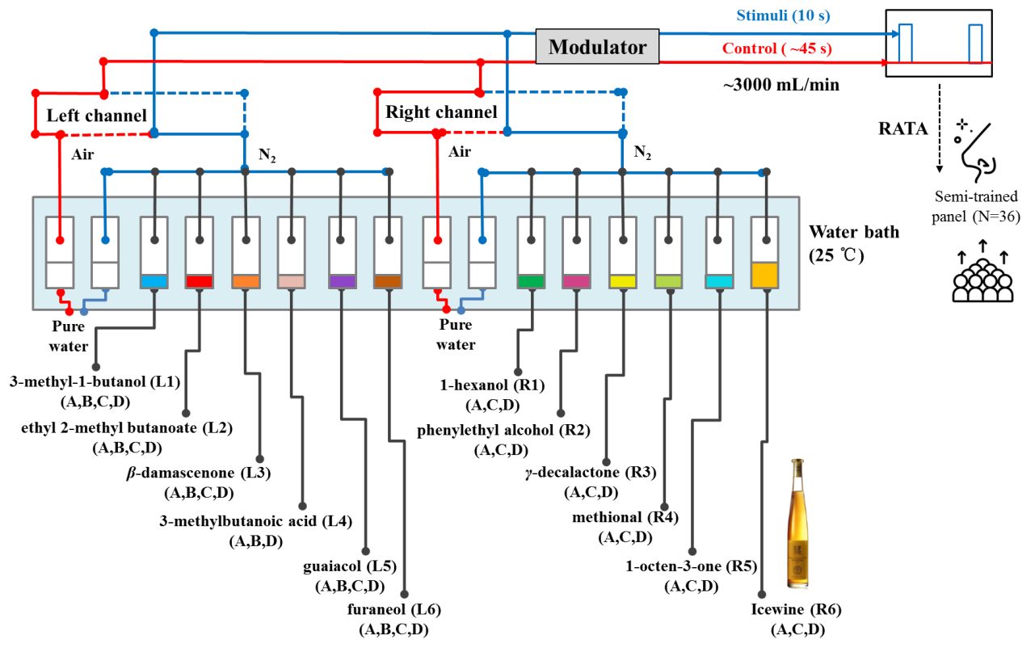

Figure 2
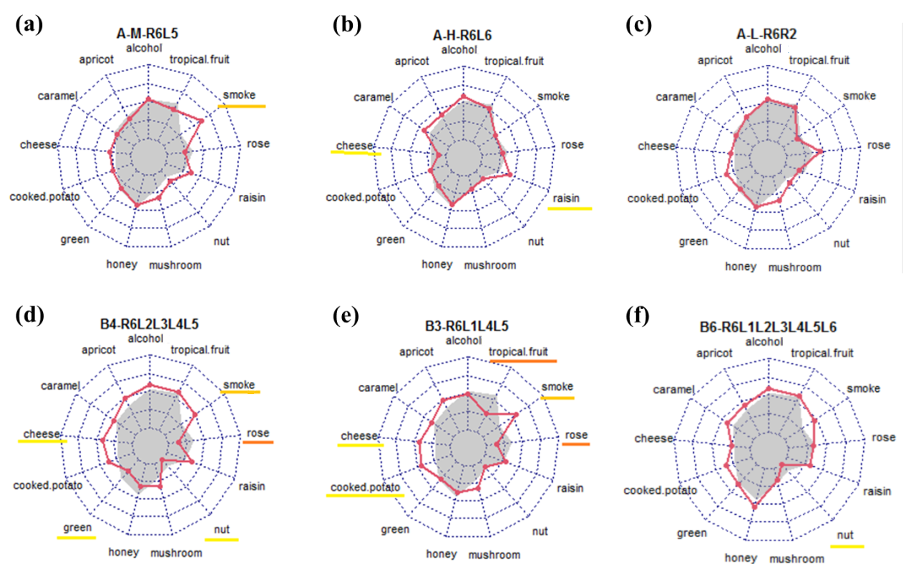
Figure 3
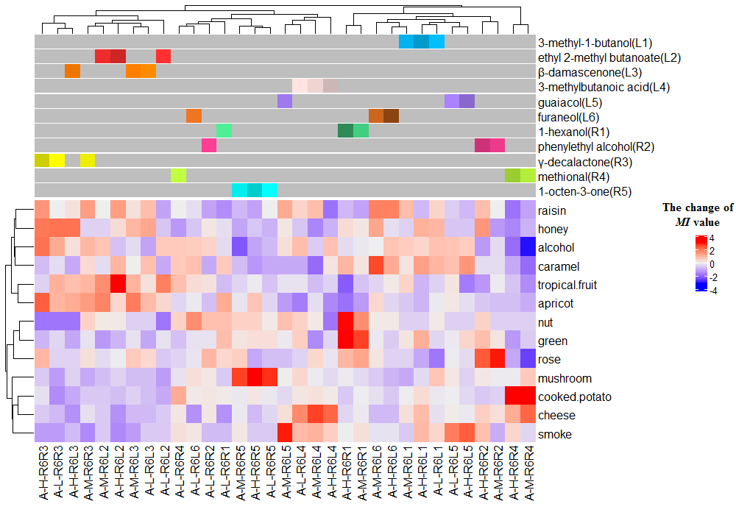
Figure 4
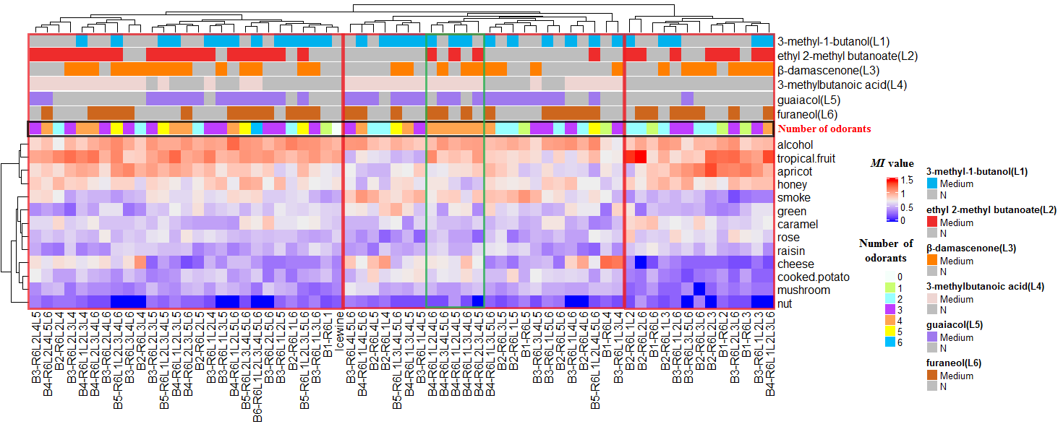

Figure 5
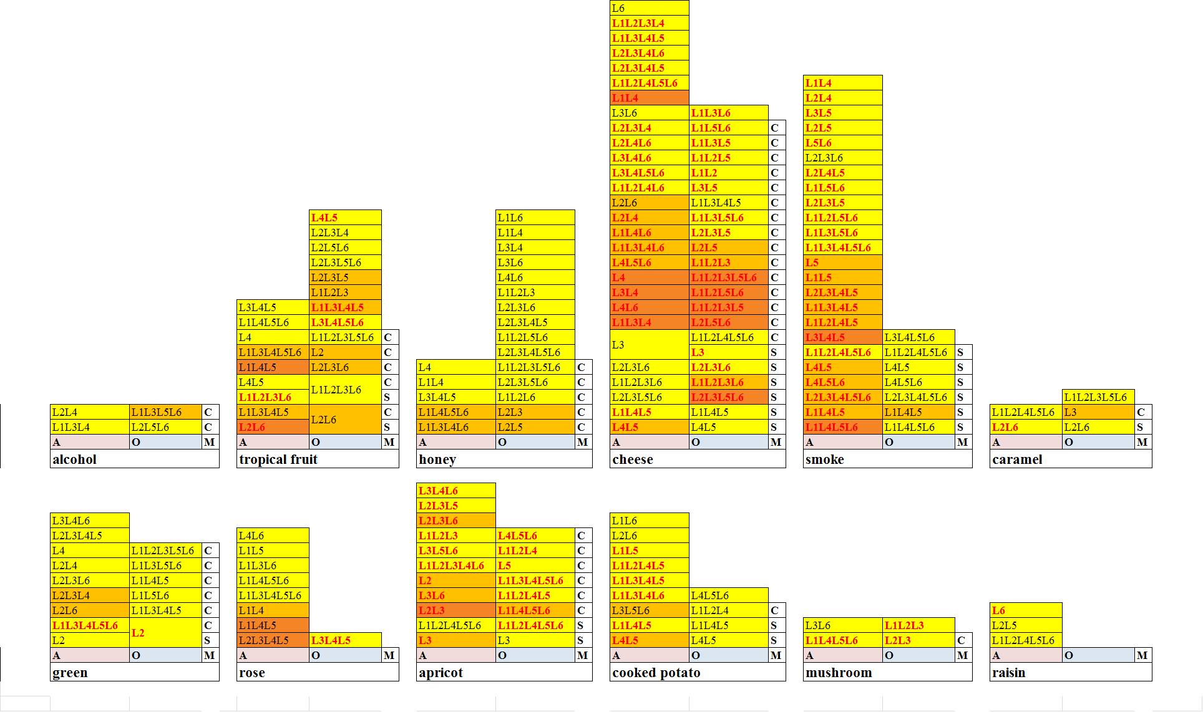
Graphical abstract
